 NARROGIN SENIOR HIGH SCHOOL

Task 9
English Year 9

Student: Teacher: Date Due:
Task 9

Assessment Type: Writing

Weighting: 5%

Task: Analytical Essay – In class assessment (55 minutes)

Question:
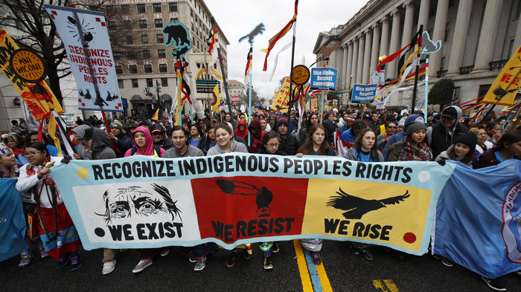

How does the image above represent Indigenous people? What does it make you think and feel about Indigenous people? Make sure to use evidence from the image when explaining your answer.

Respond to the question above in essay form using the planning sheet below to guide you.

Mark: j

/ 100

 | Year 9 Assessment Pointers – Writing and Creating
 | A Excellent achievement  80-100 16-20 8-10 | B High achievement  65-79 13-15 7 | C Satisfactory achievement  50-64 10-12 5-6 | D Limited achievement  30-49 6-9 3-4 | Total Marks
Introduction | Constructs an introduction, establishing a clear line of argument with a focused thesis statement that is developed logically in the body of the essay. | Constructs a clear introduction that addresses the question or topic and provides a specific focus for discussion in the body of the essay. | Constructs an introduction that broadly addresses key aspects of the question or topic. | Provides a brief introduction that partially addresses the question or topic, including some specific details; for example, the text and author. | /20
Paragraphs | Constructs fluent and cohesive paragraphs, using text connectives to organise ideas. | Constructs paragraphs that are well developed, using clear topic, developing, supporting and linking sentences. | Constructs paragraphs with topic, developing and supporting sentences, but sometimes repeats points unnecessarily. | Constructs paragraphs that include more than one idea or that describe ideas related to the question or topic in a general way; sometimes includes irrelevant detail. | /20
Paragraphs | Develops and supports points through incorporating appropriate evidence for example, quotes and examples, and clearly explains its significance. | Incorporates relevant evidence to support points, with a general explanation of its significance. | Includes evidence to support points and provides some explanation of its significance. | Makes generalisations without providing supporting evidence. | /20
Conclusion | Constructs an appropriate conclusion, with clear links to the thesis. | Constructs a clear conclusion that reinforces key points. | Concludes with a brief, simple summary of the key points. | Concludes with simple statements, loosely related to the question or topic. | /20
Grammar, spelling and punctuation | Expresses ideas fluently and with precision, using a range of sentence structures. | Expresses ideas clearly, using a range of sentence structures. | Expresses ideas clearly, using simple and compound sentences. Uses some complex sentences correctly. Often relies on repetitive structures. | Presents ideas, using some simple sentence structures, though some structures may detract from meaning. | /10
Grammar, spelling and punctuation | Spells familiar and most challenging words accurately, and uses punctuation with a high degree of accuracy. | Uses accurate spelling for familiar and some challenging words, and uses most common and complex punctuation correctly. | Spells common and familiar words accurately and uses most common and some complex punctuation accurately. | Misspells some familiar words and uses correct punctuation inconsistently. | /10
_______/100

Essay Planning

Deconstruct the Question

How does the image above represent Indigenous people? What does it make you think and feel about Indigenous people? Make sure to use evidence from the image when explaining your answer.

Brainstorm the topic/ideas for your essay. Look up words you don’t know.

DRAFT

INTRODUCTION

Sentence 1: What topic are you discussing? Discuss the image.

Sentence 2: State what you will be discussing in each paragraph

1.

2.

Sentence 4: Thesis statement (a short sentence explaining your overall answer to the question)

BODY PARAGRAPH 1

Topic Sentence – What you are going to talk about

Explanation Sentence – answer the question

Example Sentence – refer to evidence from the image

Linking sentence – link back to the question

BODY PARAGRAPH 2

Topic Sentence – What you are going to talk about

Explanation Sentence – answer the question

Example Sentence – refer to evidence from the image

Linking sentence – link back to the question

CONCLUSION

Restate what you have been discussing

A summary of the main points of each paragraph (look at your topic sentences)

A comment on the ideas you have presented to summarise and conclude your essay

